Installing Steel or Fiberglass Entry Systems
Tools & Materials

Insulated Entry System
Caulking
Hammer
3” Drywall Screws
Caulking Gun
Fiber Sill Sealer
6d Finish Nails
Electric Drill
Shims
Level
Carpenter’s Square
Steel Tape Measurer
Wood Filler
Sawhorses
Screwdriver
Finishing Materials
Drill Bits

If you're getting ready to replace your entry door, there's very little question that a steel or fiberglass entry system is a good choice. A significant part of the heat loss in a home occurs through the doors and windows, and an insulated entry system not only provides better R-values than a wood door, it can also do a better job of preventing air infiltration.
This document describes the basic procedures in installing a steel or fiberglass entry system. Keep in mind that the procedures may vary for different brands of systems. Wherever those instructions differ, always follow the manufacturer's instructions.

You’ll find information about:
Entry System Features
Installing an Entry System

Entry System Features
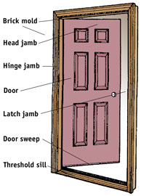
Steel and fiberglass entry systems are almost identical, except for the door itself. Steel and fiberglass entry systems are usually factory prehung and weatherstripped (Fig. 1). Wood entry doors may come prehung or where the door, frame, and hardware all come separately and have to be assembled. As a rule, prehanging provides a more weather-tight system.

Steel and fiberglass doors are very similar, too (Fig. 2). They consist of a frame, made up of vertical stiles and horizontal rails, covered with a skin of either steel or fiberglass. The door is filled with rigid foam insulation, typically either polystyrene or polyurethane. The R-values of steel and fiberglass doors range from R-7 to R-15–compared to a 1-3/4" wood door, which is approximately R-2. They provide much better insulation value.
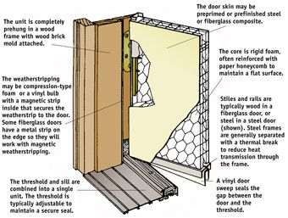
The primary difference between steel and fiberglass doors is the skin. Both may be molded to simulate a real wood door, but fiberglass doors can be stained and varnished, whereas steel doors are primed and painted. If you want a wood look, fiberglass is the best choice. If you plan to paint the door, steel is probably better, if for no other reason simply because steel is typically less expensive.
A steel or fiberglass entry system has a built-in threshold-and-sill combination that may be wood or aluminum. The weatherstripping is already applied, too. It may either be compression-type foam or a vinyl bulb with a magnetic strip inside that seals the unit much like a refrigerator door. Both offer a wide range of style accessories, including brass hardware, decorative lights, and–in the case of fiberglass–a simulated woodgrain appearance.
The frame may be steel or wood; wood is most common in residential entry systems.
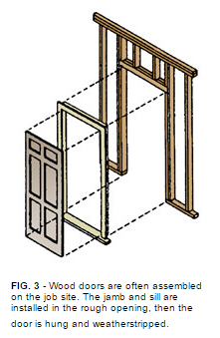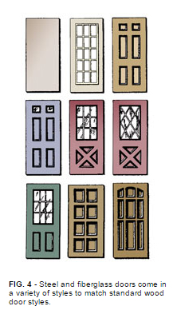
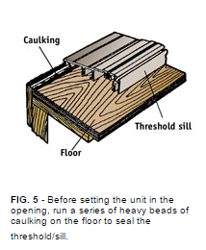
Installing an Entry System
To install a steel or fiberglass entry system, first remove the brick mold from around the door on the outside. Then remove the casing from around the door on the inside. If you remove the interior casing carefully, you may be able to reuse it.

Take the old door off its hinges, then use a reciprocating saw to cut through the nails that hold the door jamb to the wall framing. Remove the door jamb, then remove the threshold and pry up the original sill so the subfloor is exposed.

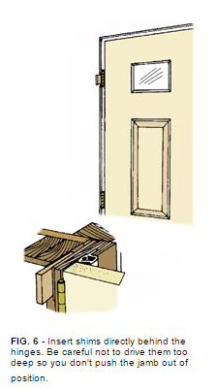
Unpack the new entry system. There may be skid boards or other framing attached to protect the system during transit. Lay the door on a pair of sawhorses and remove any protective materials. Some brands have prehanging clips that keep the door aligned and closed–if so, do not remove them.

Run beads of caulking along the floor where the threshold/sill will rest (Fig. 5). From the outside, center the bottom of the unit in the opening and tilt it up into place.

Plumb the hinge-side jamb with a level, then secure the hinge jamb to the wall framing temporarily with 3"-long drywall screws, about 2" below the top and center hinges.

Leave a space between the jamb and the wall stud. Go inside the house through another door so you can shim the unit.

Shim the hinge jamb directly behind all three hinges so it is plumb (Fig. 6). Then repeat the process on the lock-side jamb, shimming at the top, bottom, and just above and below the strike plates. Be careful not to allow the unit to be twisted; the inside edge of the jamb should be flush with the interior wall surface at all points.

DO NOT SHIM BETWEEN THE HEAD JAMB AND THE WALL HEADER.

Place a carpenter's square at the corners to make sure the unit is square; if not, add shims below the threshold/sill. Go back outside and temporarily secure the latch-side jamb with 3" drywall screws at the top and bottom of the unit.

Check again to make sure the unit is plumb, square, and not twisted, and make any necessary adjustments. Drive 3" drywall screws through the hinge jamb 2" above the top and bottom hinges, and 2" above and below the center hinge.

Remove the prehanging clips (if present), and open the door to make sure it operates properly. Go inside and close the door, then check the latch side of the door to make sure the gap between the door and jamb is even all along the length of the door. If not, the unit is out of square. Remove one or both of the screws and adjust the shims to make the gap even.

From the outside, check to make sure the weatherstripping along the latch side of the jamb makes uniform contact with the door from the top to the bottom. If not, the unit is twisted. Remove one or both of the latch-side screws and adjust the jamb in the opening until it is straight. Drive two more 3" drywall screws through the latch jamb, spaced evenly between the first two screws.

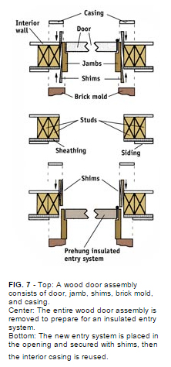
Check the bottom of the door to make sure the door sweep makes even contact with the threshold across the entire width of the door. Adjust the threshold (Fig. 8).

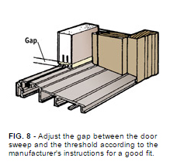
Some entry systems come with long security screws that are driven through the hinges and jamb and into the wall framing. If so, four screws will be missing from the jamb leaf of the hinges. Predrill the jamb, then drive the security screws. Double-check the clearances all around the door; if they are not even, adjust the security screws to even the gap.

Inside the house, stuff fiberglass insulation into the gap between the door jamb and the wall framing. Make it snug, but don't stuff it too tightly. Replace the interior casing.

On the outside, caulk around the outside of the brick mold where it meets the siding. Finish the door according to the manufacturer's instructions.

Check your state and local codes before starting any project. Follow all safety precautions. Information in this document has been furnished by the National Retail Hardware Association (NRHA) and associated contributors. Every effort has been made to ensure accuracy and safety. Neither NRHA, any contributor nor the retailer can be held responsible for damages or injuries resulting from the use of the information in this document.

