Working with Screens
Tools & Materials

18” x 16” or 18” x 14” Screening
Heavy-Duty Scissors
Try or Framing Square
Utility Knife
Screen Moulding
Drill and Bits
Long-Nosed Pliers
Tack Hammer
Sawhorses
Dowels, 3/8” or ½”
Shop Vacuum with Upholstery Brush
Exterior Trim Paint
Paint Solvent
Clean-up Rags
Stiff-Bristled Brush
2 C-Clamps, 3” or larger
Plastic Spline Material
Snap-On Screen Patches
Heavy-Duty Stapler
Measuring Tape or Rule
Claw Hammer
Nail Set
Screwdriver
Metal Snips
Spline Tool
Screws
Mending Plates
Paintbrush or Pad
1x2 and 1x4 Stock
Sandpaper, 80 or 100 Grit
Garden Hose
2x4 Boards
Exterior Wood Glue

Repairing and replacing screens fits easily under the heading of do-it-yourself projects. Screen repair is among the simplest of jobs. In this document, you will find:
Screen Repairs
Replacing Screening in Wood Frames
Replacing Screening in Metal Frames
Frame Repairs
Painting Screens
Cleaning Screens

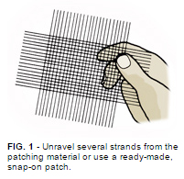
Screen Repairs
You can easily patch most small holes. It's only when a hole exceeds about 3" in diameter that the screening itself needs to be replaced.
Measure hole sizes and purchase ready-made, snap-on repair patches or cut them from new screening. A patch should be at least 1/2" larger in diameter than the hole. For bigger holes, the patch should be as much as 1" larger.

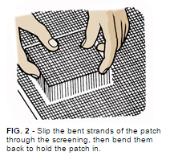
For metal and most fiberglass screen patches, use this procedure: Unravel a number of strands around the edges of the patch one or two rows back from the edges, depending on the patch size (Fig. 1). Then weave the strands through the screening and bend them tight (Fig. 2). You can usually bend the strands with your fingers, but if the patch is heavy duty, you may need long-nosed pliers. Plastic patches need a touch of household cement on the ends of the strands after they've been woven through.

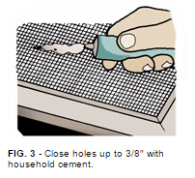
You can patch small holes–1/4" to 3/8"–with a small amount of household cement (Fig. 3). This glue patch will be next to invisible.
Fiberglass and plastic screens are tough to patch and should probably be replaced.

Replacing Screening in Wood Frames
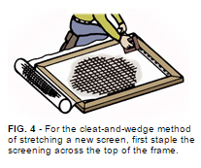
To remove the old screening, pry off the screen molding, starting in the center of a strip and working toward the ends. Try not to break it.
Your local retailer can help you decide what type of new screening to use. For general household screening, you need a mesh of 18" x 14" or finer (these are the stand counts in each direction, per inch).
With wooden window and door screens, it is important to stretch the screen fabric drum-tight for a neat and long-lasting job. For the wedge method of stretching, you'll need some 1x2 stock in a length slightly wider than the window or door and some 1x4 stock from which to saw out the wedges.
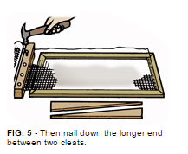
Cut your new screening at least 1' longer and 1' wider than the unit to be recovered.
Staple the screening across the top edge (Fig. 4). Then install the 1x2 cleats with the bottom cleat nailed to a bench or other flat surface. Roll the screening over it, then nail on the top cleat (Fig. 5).
Insert the wedges between the cleats and screen frame, tapping the wedges in until the screen has been pulled taut. Fig. 6 shows the procedure.
Staple the screening at the bottom, then along the sides. Put a staple in every few inches (Fig. 7).
Snip off any excess screening, and use brads to refit the screen moldings. Countersink the brads and fill the holes with wood putty.

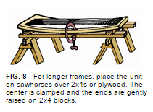
The cleat-and-wedge method works well with window screens and halves of doors, but there's a better method of stretching screen material on larger units, such as doors. You'll need a pair of sawhorses with two 2x4s about the same length as the screen placed across them (or use a sheet of plywood). Place the stripped fame on the boards, holding the center with C-clamps. Then lift each end and insert short 2x4 blocks to bow them (Fig. 8). Bowing needs to be done slowly and gently to keep from snapping the frame.
Now staple the screen in place tightly, starting at the center brace. Remove the 2x4 blocks and the screen will be quite taut as you replace the screen moldings.

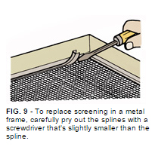
Replacing Screening in Metal Frames
Aluminum screens or screen doors require a different technique.
Without kinking the metal frame, remove the splines that hold the old screen in place (Fig. 9). Check to see if new splines are needed. For replacement, vinyl splining is excellent. It comes in rolls of various widths.
Use a square to make sure the frame is still in decent shape. Reshape it if not.
Cut new screening to the frame's outside measurements (Fig. 10).
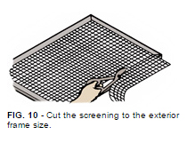
Next, force the screen's edges into the channel on the top and one side using the convex-edged wheel of a spline or screen installation tool (Fig. 11). These tools are available with different-width rollers–use one that matches the channels in your screen frame. Use short strokes for the best results. A putty knife will work, too.
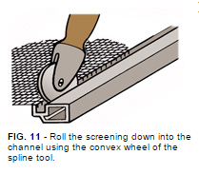
With a sharp utility knife, cut the screening to fit the two remaining sides. Use the outside edge of the retaining channel as a guide. Use the spline tool to roll the screening into the remaining grooves.
Use the concave-edged wheel of the spline tool to roll the retaining strips or splines into the channels (Fig. 12). As before, make short strokes. As the spline goes in, it will pull the screening taut. To complete the installation, cut off any excess screening around all four sides.

Frame Repairs
Screen frame repairs are easiest to make on wooden screen doors and windows. You may need wood glue, dowels, corrugated or chevron fasteners, mending plates and wood screws, depending on the condition of the frame. The fasteners work best on mitered-corner screen frames.
If the joint is slightly loosened but the material is intact, open it up enough to apply wood glue. Use a glue that's suited for outdoor exposure (ask your retailer).
Along with re-gluing, you may want to install a mending plate of the proper size. Flat and angled plates are available in many sizes; use the largest size that fits without causing problems. Secure the plates with wood screws, which are often included. Make sure the screws don't come through the back of the frame.
For making a simple repair at a slightly damaged corner, you have two choices. You can use a wood screw from the undamaged edge or a dowel from either edge (with glue). Drill and countersink for the wood screw, using as large a size as practical. A 2-1/2" No. 10 screw is probably the smallest screw that's strong enough to last. Fill the countersink hole with putty.
For a dowel, drill for at least a 3/8" diameter dowel. A 1/2" dowel is even better. Dowels need to be slightly undersized for their holes with a tap fit. Take care to see that the dowel runs on into undamaged wood.
Coat the dowel with glue and tap it into the hole.
With dowel and wood screw repairs, the holes should extend into both pieces of the frame. If the frame shows signs of twisting, you'll need to use two slightly smaller dowels or two wood screws.
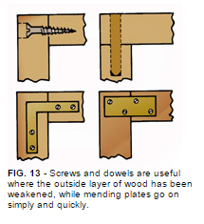
Fig. 13 shows four types of screen corner repairs using a wood screw, dowel and two types of mending plates.
Aluminum frame repairs are limited to rebracing of corners. Or you can get extruded metal frame stock and make new screens. A cross-brace kit is also available, if needed, with turnbuckles and clamps to draw a sagging screen door back into square and hold it there.
For frame or corner repairs, check the squareness of the frame, then use mending plates and sheet metal screws to make repairs or to reinforce those corners. Be sure that the mending plates you use are the same material as the frame. This will help prevent corrosive electrolysis between dissimilar metals.

Painting Screens
In most cases, only wood-framed screens ever need painting. Choose the paint to match the window frames. Select painting tools that are suited for use on small surfaces. If you have the old screening off and find that the frame needs painting, do it while the screen is off.
On wood screens, remove the old, torn screening as the paint coat under the molding and screen provides protection. Make sure the coating is light, though, so the molding fits on replacement.
Don't try painting screen mesh. If your screens have galvanized screen mesh, replace them if they rust. Painting aluminum or fiberglass screening is only a waste of time and paint.

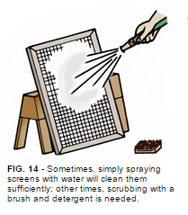
Cleaning Screens
To clean screens, first try vacuuming them while installed. An upholstery nozzle usually does the trick.
In some cases, airborne dirt cannot be removed simply by vacuuming. Then the screens must be taken off and washed. With luck, a hard spray from a garden hose will do the job (Fig. 14). In other cases, you'll need to scrub the screens. Do this with a stiff-bristled brush and a mild detergent solution, and finish by rinsing with the hose.

Check your state and local codes before starting any project. Follow all safety precautions. Information in this document has been furnished by the National Retail Hardware Association (NRHA) and associated contributors. Every effort has been made to ensure accuracy and safety. Neither NRHA, any contributor nor the retailer can be held responsible for damages or injuries resulting from the use of the information in this document.

